**PAKISTAN PRIMARY SCHOOL**

**GRADE: 04**

**MATHEMATICS**

**Chapter - 1: Numbers**

**TOPIC:  Skip counting on number line**

**What is skip counting?**

In math, skip counting can be defined as the method of [counting](https://www.splashlearn.com/math-vocabulary/counting-and-comparison/count) forward by numbers other than 1.

To skip count, we keep adding the same number each time to the previous [number](https://www.splashlearn.com/math-vocabulary/number-sense/number).

Here, we are skip counting by 2 on a number line. So, starting at 0, the next [number will](https://www.splashlearn.com/math-vocabulary/number-sense/number-line) be 0 + 2 = 2, then, 2 + 2 = 4, then 4 + 2 = 6, then 6 + 2 = 8, and then, 10, 12, 14, 16, 18 and so on.

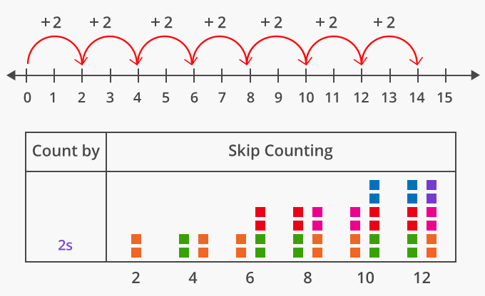

We can skip count by any number. Here’s how skip counting by numbers 2 to 10, begin to form patterns, starting at 0.

